House Price Prediction — Summary Report
Internship Project, Week 1 | Dataset: Housing Prices Dataset (Kaggle) — 545 records, 12 features
Prepared by: Sridhar S | Sridharreddyrudra@gmail.com

Model Performance
Model | MAE | RMSE | R² Score
Linear Regression | ₹407,713 | ₹506,603 | 0.868
Random Forest | ₹465,936 | ₹570,956 | 0.832

Key Findings
- Area (square footage) is by far the strongest predictor of price, accounting for over 80% of feature importance in the Random Forest model.
- Bathrooms, air conditioning, parking, and number of stories each have a smaller but positive influence on price.
- Linear Regression (R² = 0.868) slightly outperformed Random Forest (R² = 0.832), suggesting the price relationship in this dataset is close to linear.
- Bedroom count alone is a weak price signal — a small home with many bedrooms is not necessarily worth more than a large home with fewer bedrooms.

Visual Highlights
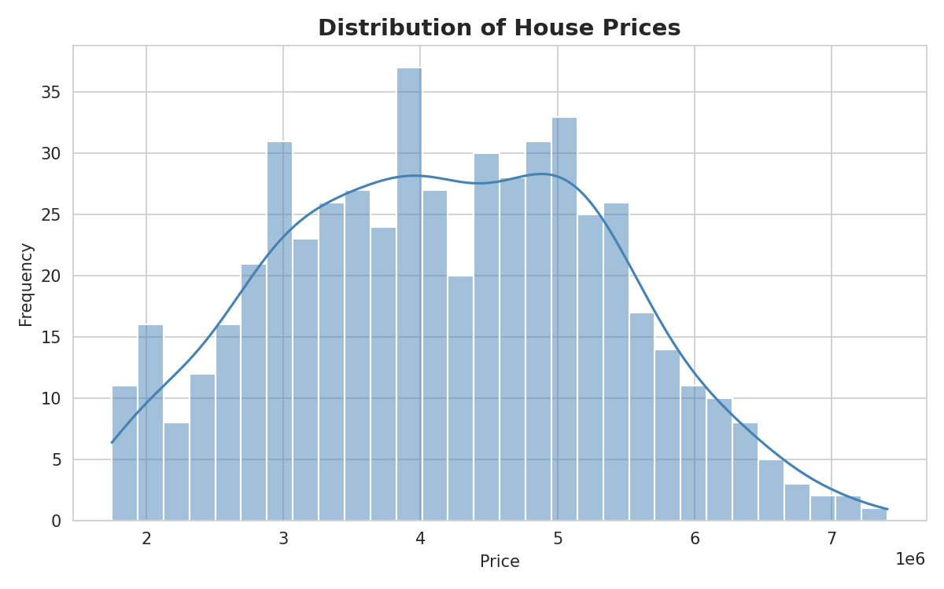  Price Distribution | 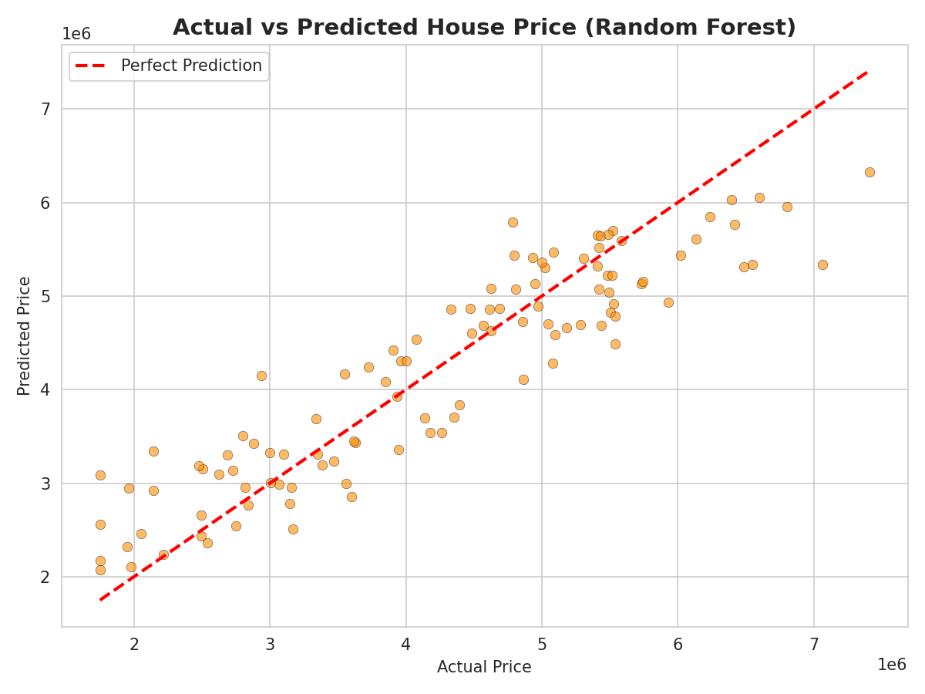  Actual vs Predicted Price

Recommendation
Real estate businesses should benchmark listings primarily on price-per-square-foot within comparable amenity tiers, rather than relying on bedroom or bathroom counts alone. This approach better captures true value and reduces mispricing of small, room-dense properties or large, amenity-light ones.

